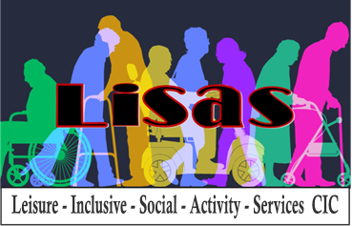

**VOLUNTEERS ROLE DESCRIPTION**

|  |  |
| --- | --- |
| **About us** | LISAS is a Community Interest Company (CIC) that provides social groups and outings for over 50’s. Group sessions are currently based in Cleckheaton, Birkenshaw and Heckmondwike. |
| **Volunteer role** | A LISAS volunteer would help to support members at one or more weekly group sessions and at the outings that are offered which are, on average, every two months. |
| **Purpose of the role** | To support the group leader to ensure members are welcomed and included in group activities and during outings. |
| **Where you will be located** | Our current groups are held at:   * Our Lady Of Unfailing Help & St Paul Of The Cross Parish Hall in CLECKHEATON, on a Tuesday 10am – 11.30am * The Salvation Army Church in HECKMONDWIKE (dementia group), on a Tuesday 12.45 – 14.15pm * Birkenshaw Methodist Church in BIRKENSHAW, on a Wednesday 1pm – 2.30pm & on a Thursday (dementia group) - 1pm – 2.30pm   LISAS is an expanding organisation and there may be opportunities to develop groups at other times and in other locations. |
| **The volunteer role typically involves the following tasks** | * Helping set up the room for activities * Welcoming members on arrival * Serving refreshments * Supporting and assisting members with activities such as quizzes, group games, crafts, baking, and bingo * Supporting members who have additional needs e.g.   + Mobility needs,   + Learning difficulties,   + Health conditions and other disabilities, such as     - Visual impairment,     - Hearing impairment,     - Age related conditions,     - People who have had strokes,     - Dementia * Encouraging members to engage in conversation with each other * Assist in tidying up at the end of the session * Participate in a de-brief * Supporting and assisting members whilst on outings   **Please note you will not be expected to carry out any personal care or personal manual handling.** |
| **Days and times** | The role is flexible, you might be able to help weekly, monthly or now and again. Each session lasts 1.5hrs and volunteers usually arrive 30 minutes prior to the start of the session to help set up and then stay at the end to help clear up. In total around 2.5 – 3 hrs per session. |
| **Desired skills and experience** | * 18 years or over * A friendly, approachable and patient individual * Experience of working, or interacting, with older adults who may be vulnerable would be an advantage * An ability to follow procedures including health and safety and safeguarding |
| **Support provided by LISAS CIC** | * Induction and training * Regular support meetings to encourage sharing of information and ideas * Reimbursement of travel expenses in line with our expenses policy * You will be part of a friendly and welcoming team * You will have an opportunity to develop your skills and experience in a supportive environment. * It may be possible to take part in courses that could enhance your experience of volunteering with LISAS CIC, such as MAGIC (Movement And Games In Chairs) training. |
| **Recruitment process** | * Application form to be completed * Character references required * Informal chat * DBS (Criminal Record Check) required. |